Lab Notebook

Brandon Steup

12/14/2016

METC 143

Lab 1 Hardness Test Lab

Date: 12/14/2016

Hypothesis:

Parts: One Rockwell Hardness Tester

One C1010 Steel Pipe Test Sample

Tools: Electronic Rockwell Hardness Tester

Procedure:

1. Ensure machine is calibrated
2. Lower pedestal and place sample
3. Raise pedestal to testing bit, ensuring that it is not too close
4. Wait for test to complete, and record reading from machine

Results:

1. The pipe hardness was read at 57.9, and that is not within the 80 to 85 specification mandated in the production specs
2. I would recommend that the parts that have been ran prior to this one be checked for quality, and re calibrate the production machine and check the specs loaded into the mechine to ensure that all parts afterwards are well within spec
3. The only thing to be done is for all pipes that do not meet the spec requirements be scrapped and recovered, and for qc checks to be ran on parts afterwards until we are sure that the parts being produced are back within spec

Conclusion:

The pipe that we tested was not near to being within specification, and this could have caused major issues if it got out to a customer, catching it allowed for correction to be made and quality and spec to be maintained.

Lab 2 and Safety Factor

Date: 12/14/16

Purpose: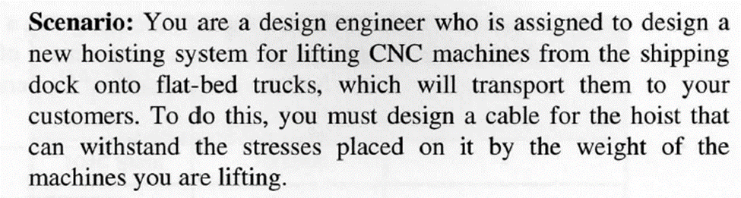

Procedure:

I ran through the worksheet required and answered the questions posed regarding safety factor

Results: Show work and answers to calculation questions. Must include formulas used etc.

1. I used the safety factor formula (Insert formula picture here) and came out with a safety factor of 7.65308
2. 5
3. Using area of a circle to find cross sectional area, I came up with 4.9, then using that in true stress formula it resulted in 3469.39. Using a modified safety factor formula in which I isolated Sm on the one side and devided 17000/8, I came up with a strength of 2125
4. I would select 1045 Steel due to its high breaking point and fit for an 8 safety factor.
5. The numbers that I used had flaws due to calculation errors on my part, I could not figure out how to decern the material strength from the information given

Conclusion: Answer the following questions:

1. What point is used as the safety factor for ductile material?

In a ductile Material the Yeild point is used because if a part has reached this point, it will start to deform and may not be able to preform its function, therefore designing from this point for safety factore keeps a part from heacing the yield point and failing.

1. What point is used as the safety factor for brittle material?

The Tensile strength point is used to prevent the material from fcactureing and failing.